Fare Free London “Winning free public transport” event

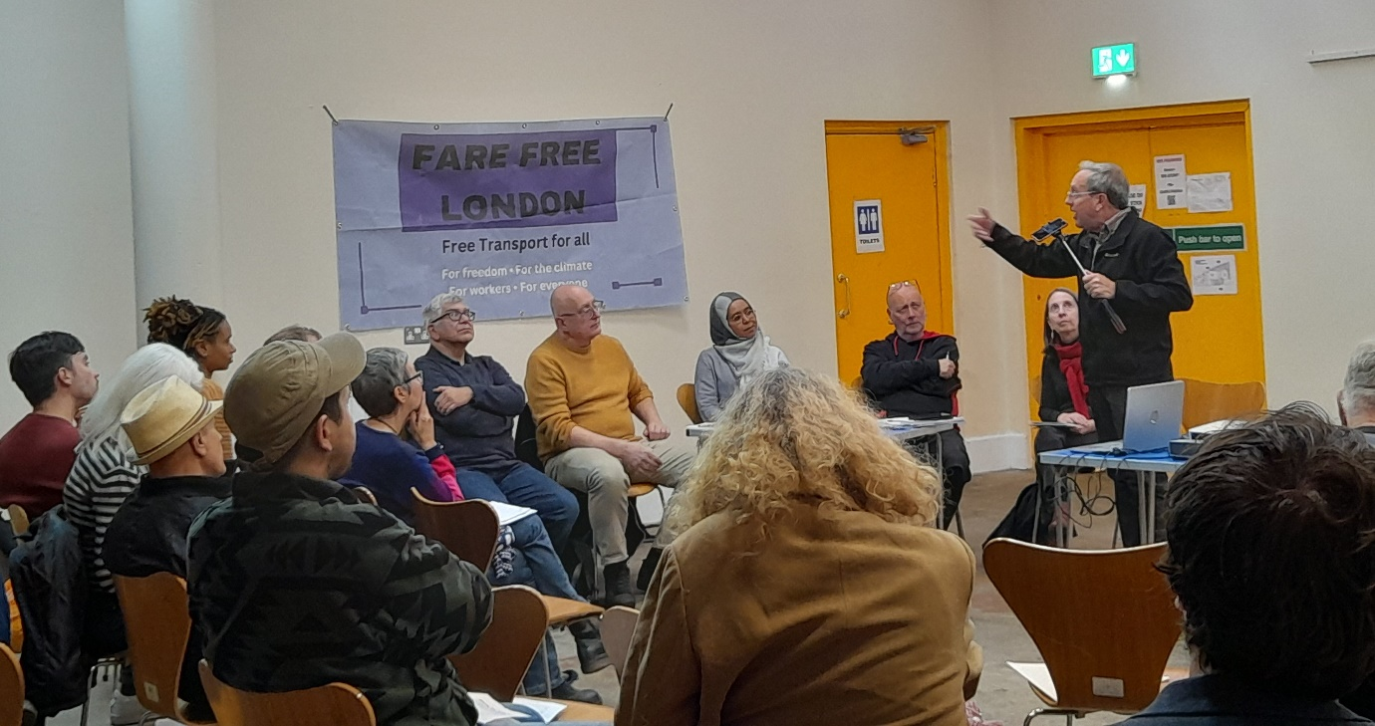

On 29 September, 50 transport campaigners, trade unionists, environmentalists and others gathered at a “Winning Free Public Transport” event organised by Fare Free London. Others joined on line.
The gathering, at the Waterloo Action Centre, heard Jerome Serodio from a campaign network in France, and Daniel Santini (speaking on zoom) from Brazil, explain how free public transport works in many cities and towns in those countries. In Brazil, 110 municipalities have made public transport free.
Mallige, from Karnataka in India, also joined by zoom, and reported on the highly successful scheme there providing free public transport for women. Since it was introduced in 2023, women in the state have taken more than 2 billion – yes, you read it right, 2 billion – free rides.
Ellie Harrison from Get Glasgow Moving was also on the international panel. Lisa Hopkinson of Transport for Quality of Life, underground train driver Dan Randall, sustainability researcher Drew Pearce and others put the case for free public transport in the UK.
You can read all the presentations, and read about our campaign plans, here. https://www.farefreelondon.org/resources

